OUTPUT SCREENSHOTS

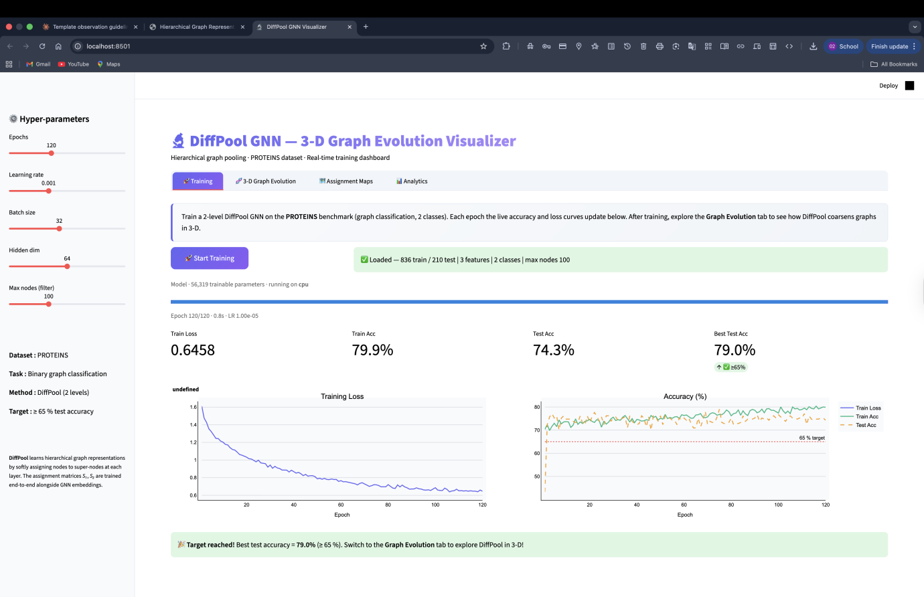
DiffPool GNN Visualizer Dashboard during training, displaying real-time loss and accuracy curves for the PROTEINS dataset

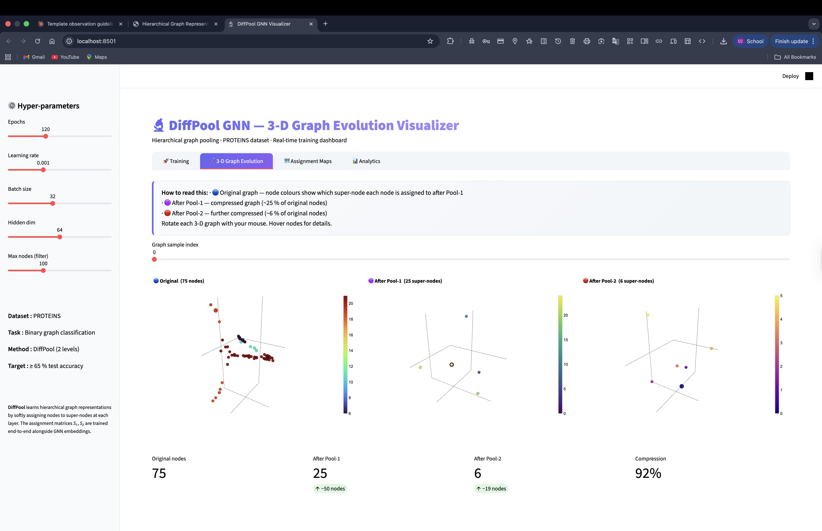
3-D Graph Evolution tab illustrating hierarchical node compression across pooling layers, achieving 92% structural compression

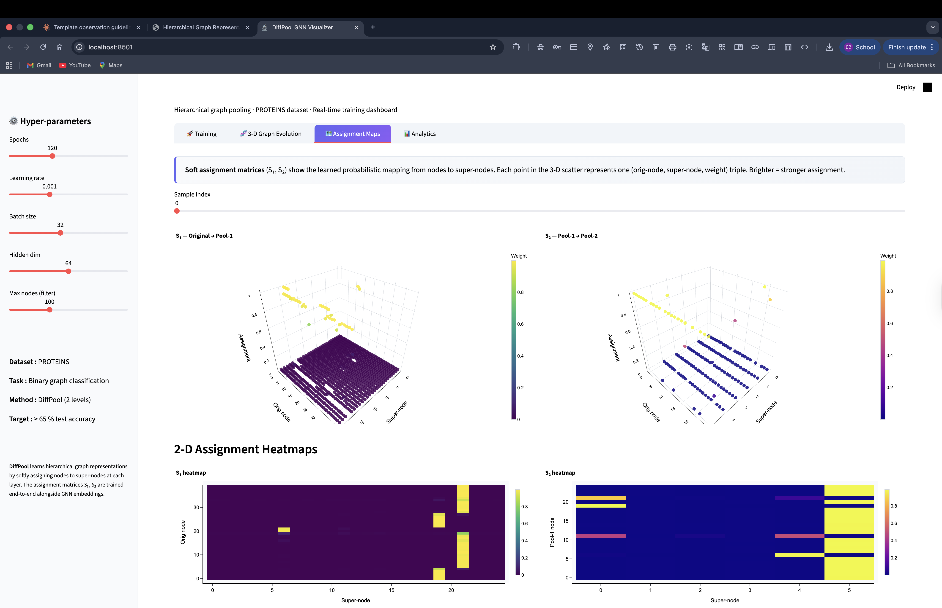
Assignment Maps visualization showing the learned soft assignment matrices (S1, S2) via 3-D scatter plots and 2-D heatmaps

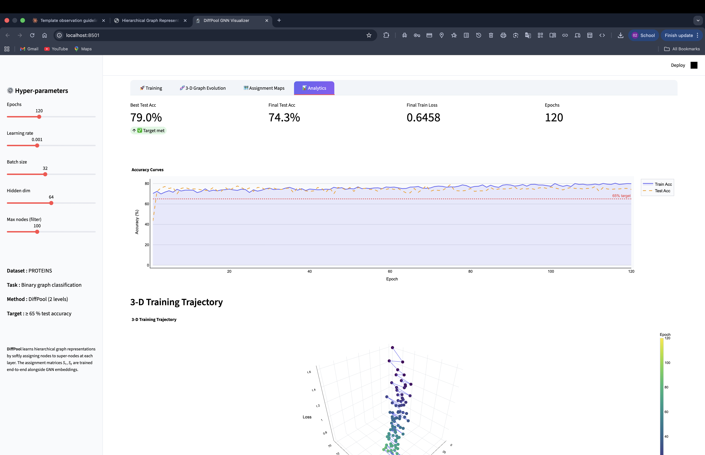
Analytics tab displaying the final evaluation metrics, accuracy curves, and a 3-D Training Trajectory mapping the optimization path

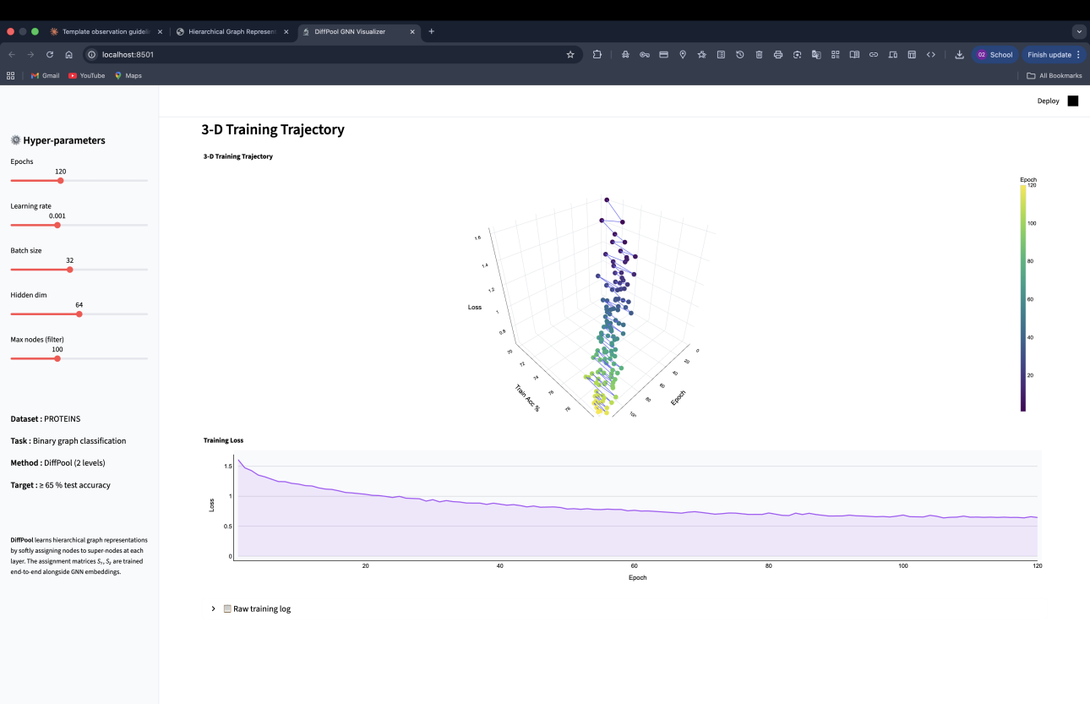
Detailed view of the 3-D Training Trajectory alongside the overall training loss progression curve

